Francis Lapointe

11/19/2024

Operating Systems

Simulation test plans:  
First in First out: Using a for loop generate a series of jobs calculating and outputting the average turnaround time and information about the jobs along with different durations.  
Round Robin: using a for loop generate a series of jobs calculating and outputting the average turnaround time and information about the jobs along with different durations.  
Multilevel Feedback: using a for loop generate a series of jobs calculating and outputting the average turnaround time and information about the jobs along with different durations.  
  
Outputs:  
5 Jobs, max duration 2000 arrival time incremented by i \*2:

5 jobs, max duration 200 arrival time incremented by i \*2:

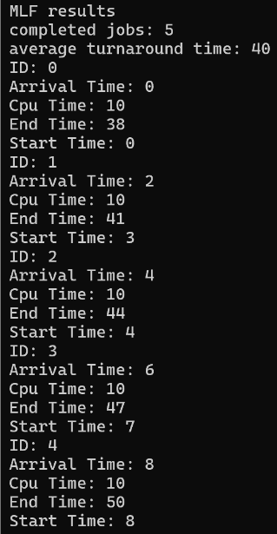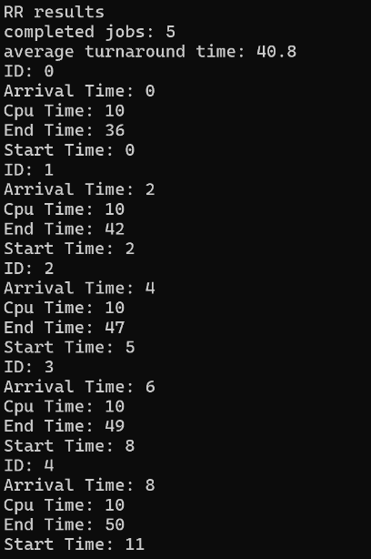5 jobs, max duration 200, arrival time incremented by i \* 4:

50 jobs, max duration 2000, arrival time incremented by I \*2:  
5 jobs, max duration 2000, cpu time 20, arrival time incremented by I\*2;  
5 jobs, max duration 2000, cpu time incremented by i\*2 – i, arrival time incremented by i\*2;

Observations: While Round robin and MLF are very close in efficiency as the arrival time of jobs increase First In First Out still beats them in terms of average turnaround time. In terms of MLF vs Round Robin they tend to overtake each other by a couple seconds at most during testing.